Van Lang University

**Software Measurement and Analysis course**

**Report Viking’s Project at Week 28**

Version number: 1.0

Author: K14T01 – Team 01

Team member:

Duong Nguyen

Mung Nguyen

Manh Nguyen

Binh Huynh

Hien Nguyen

Table of Contents

1) **Introduction :** 1

2) **Viking’s Project Overview :** 3

3) **Viking Summary Earned Value report :** 5

4) **REFERENCE :** 7

List of Table

Table_1 : Data represent

Table 2: Schedule Slippage at Week 28

List of Figure

Figure 1: Viking’s Project Overview

Figure 2 : Release 3 – Earned Value Report

Figure 3: EV Viking’s Project

Figure 4: Bull ‘s eyes chart of Viking Project

1. **Introduction :**

This project will be monitored and controlled by a using a select set of the Earned Value Management (EVM) metrics: Schedule Performance Index (SPI) and Cost Performance Index.

In order to effectively use CPI and SPI, the project will be partitioned by Control Account Plans (CAPs, Project Deliverables. The Earned value data will be captured from weekly timesheets produced by all team members. The Viking Project Management team is chartered to incorporate the week time into the schedule, calculate the metrics, and perform causal analysis. This information will be summarized and presented to the Steering Committee in association with the charts.

Data represent in chart include :

|  |  |
| --- | --- |
| Data Field | Description |
| **BCWS** | Budgeted Cost of Work Scheduled. ... For a <Resource>, it is the rolled-up summary of a resource's BCWS values for all assigned tasks |
| **BCWP** | Budgeted Cost for Work Performed; Earned Value; the dollar amount of work that was actually accomplished; [Budget] X [percent complete] |
| **ACWP** | Actual Cost of Work Performed during a given time period; money spent up  to the current date. ... Cost Performance Index, CPI = BCWP / ACWP |
| **CPI** | Cost Performance Index is the calculation of Earned Value (EV) divided by Actual  Cost (EC), CPI = BCWP/ACWP |
| **SPI** | Schedule Performance Index is the calculation of Earned Value (EV),BCWP  divided by the Planned Value (PV), a.k.a. SPI = BCWP/BCWS |
| **EAC** | The EAC gives an idea of the final costs of a project. It takes into account the  original budget (BAC), the Earned Value and the Cost Performance Index of the  already completed works.  EAC = ACWP + ((BAC - BCWP)/CPI |
| **BAC** | Budget at Completion is the original budget requested for the project or program represented by the end point on the BCWS curve |
| **SV** | Schedule Variance . SV = BCWP - BCWS |
| **CV** | Cost Variance . CV = BSWP - ACWP |

***Table_1 : Data represent***

The Earned Value data in this assignment will be collected from Viking_EV_Data-up_to_w28.xls.

1. **Viking’s Project Overview :**

**To:** Mr.Hieu, ABC System **From: Team 01**

**Subject:** *Summary Report Viking’s Project at Week 28* **Date**: *10/28/2010*  **Version** : *1.0*

|  |  |  |  |
| --- | --- | --- | --- |
| **Project Name:** | **Viking ‘s Project** | **Report Period:** | **Week 28** |
| **Project Manager:** | **Team 01** | **Phone** | **0999.999.999** |
| **Project Description:** | **Management Software** | **E-mail:** | **k14t1-g1@googlegroups.com** |

**Project Status Summary:**

**_____Green:** Green can mean the project is on track for hitting schedule, cost, and requirements (scope) goals, and there are no major issues

**_____Yellow:** Yellow can mean early warning of potential risk to either cost, schedule, or scope, and refer the reader to the Issues section for details

**_____Red:** Red can mean that one or more serious issues have put project success in jeopardy

The figure below shows an overview of the project. The project that has completed two releases is located in July. The project is doing third release. We accomplished R1 & R2 on time. R1 accomplished at Week 16, R2 accomplished Week 24.

Accomplished

* Finished R1 & R2

Next

* Doing R3
* Repair Do R4

Current Schedule Time

R1 W16 R2 W24 R3 W36 R4 W4 Close

|  |  |  |  |  |  |  |  |  |  |  |  |  |
| --- | --- | --- | --- | --- | --- | --- | --- | --- | --- | --- | --- | --- |
| M1 | M2 | M3 | M4 | M5 | M6 | M7 | M8 | M9 | M10 | M11 | M12 | M1L |

Start Kick-off R1 R2 R3 R4

Report at Week 28

Issue

* R3 may be delay 4 week

Risk

* Project will be delay 6 week

Figure 1: Viking’s Project Overview

|  |  |  |  |  |  |  |
| --- | --- | --- | --- | --- | --- | --- |
| Summary Task | Baseline | | Current | | Release Status | Note |
| S | F | S | F |
| PM & EV | W 1 | W 48 | W 1 | W 48 | On Target | As per schedule |
| Release 1: GUI & Documentation | W 3 | W16 | W 3 | W 16 | Completed | Completed on time |
| Release 2 : Online Product | W 3 | W16 | W 3 | W 24 | Completed | Completed on time |
| Release 3 :  Offline Product | W 3 | W36 | W 3 | W 40 | Behind Schedule | Behind Schedule 2,5 Week |
| Release 4 :  Final Product | W 36 | W 48 | - | W54 | Not Started | Potentially behind schedule by 6 or more weeks because of the delay in critical path |

Table 2: Schedule Slippage at Week 28

1. **Viking Summary Earned Value report :**

The figure below shows Earned Value Report of third release.

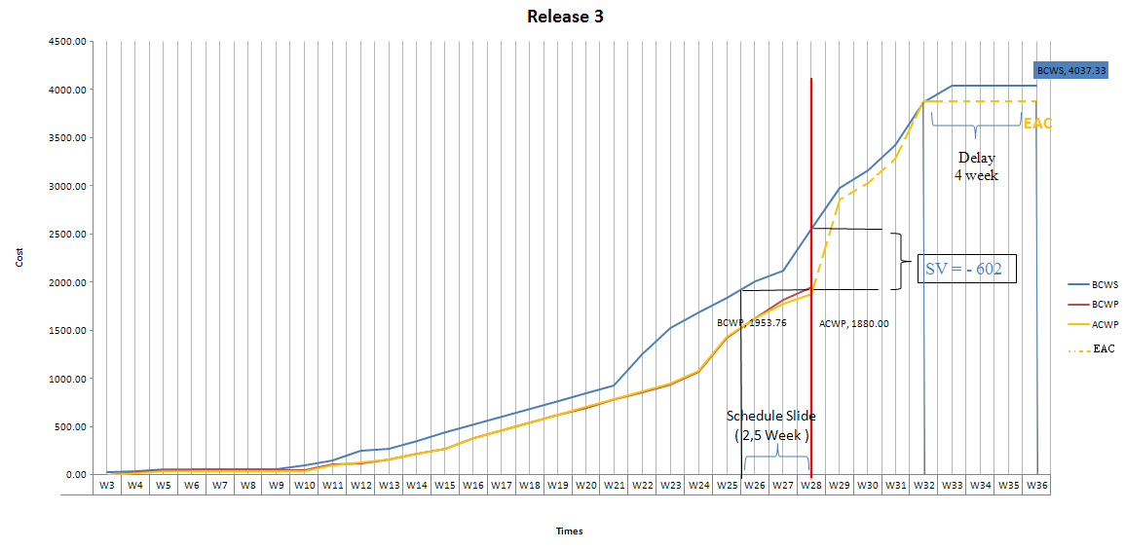

Figure 2 : Release 3 – Earned Value Report

The figure below shows Earned Value Report of Viking Project

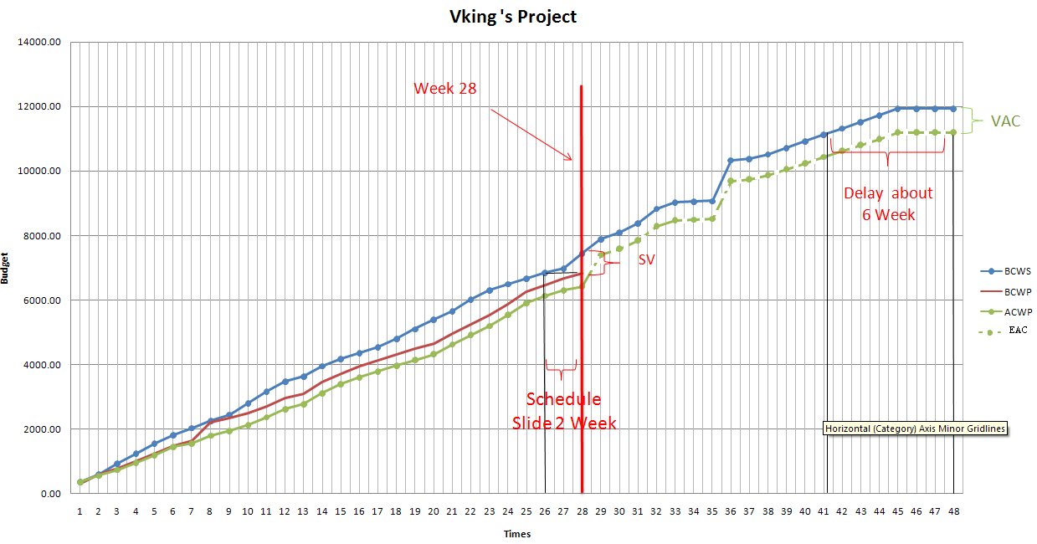

Figure 3: EV Viking’s Project

Look at the Figure. Base on BCWS and BCWP line, we can see variance. That is make project Slide about 2 week. With Currency performance, Project Will be delay about 6 week. From Start Period to End Period, Actual Cost budget are Cheaper than Schedule Cost. So, We are successful in save project budget

The figure below shows Bull’s Eyes Chart of Viking Project to present trend of project.

In Viking Project at week 28:

* BCWS = 7443.27
* BCWP = 6840.62
* ACWP = 6420.00
* BAC = 11928.20

Cost Variance (CV) = BCWS – ACWP = 7443.27 – 6840.62 = 420.62

Schedule Variance (SV) = BCWP – BCWS = 6840.62 – 7443.27 = -602.65

Estimate at Completion (EAC) = BAC / CPI = (11928.20 * 6420.00)/ 6840.62 = 11194.75

Estimate to Complete (ETC) = EAC – ACWP = 11194.75 – 6420.00 = 4774.75

*→ The project is behind schedule by $602.65 (2 week or more) and below cost by $420.62*

*→ At the current rate, the project performance will be such that it will be completed in $11194.75 as opposed to a planned budget of $11928.20. Comparing with Figure_3, the project can be delayed 4 – 6 week or more.*

*→ Project performance at this rate means that the project requires $ 4774.75 to be completed.*

The figure below shows Bull’s Eyes Chart of Viking Project to present trend of project.

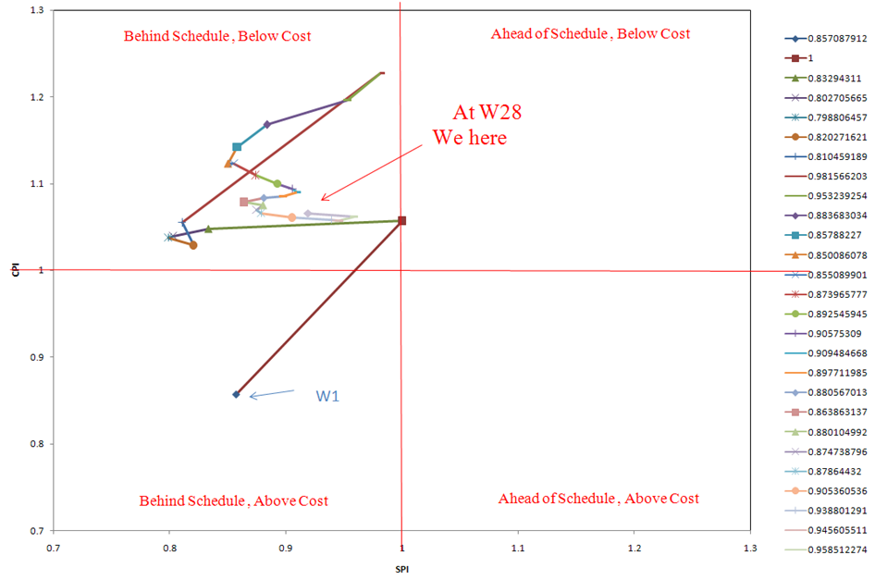

Figure 4: Bull ‘s eyes chart of Viking Project

In Week 1, the result’s project are not good, Behind Schedule, Above cost. But Fewer and fewer, the result are better. At week 28, Project are Behind Schedule, Below Cost.

1. **REFERENCE :**

Besides, You can read detail EV in *K14T01_Team01_TeamAssignemnt 9.xlxs* Document